LAB Logbook

Lab 1

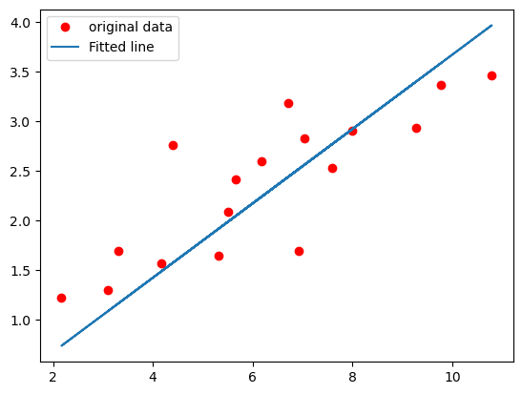

Lab 2

0.96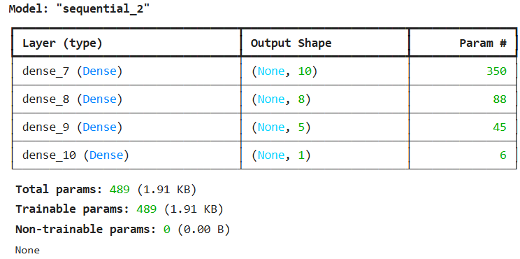

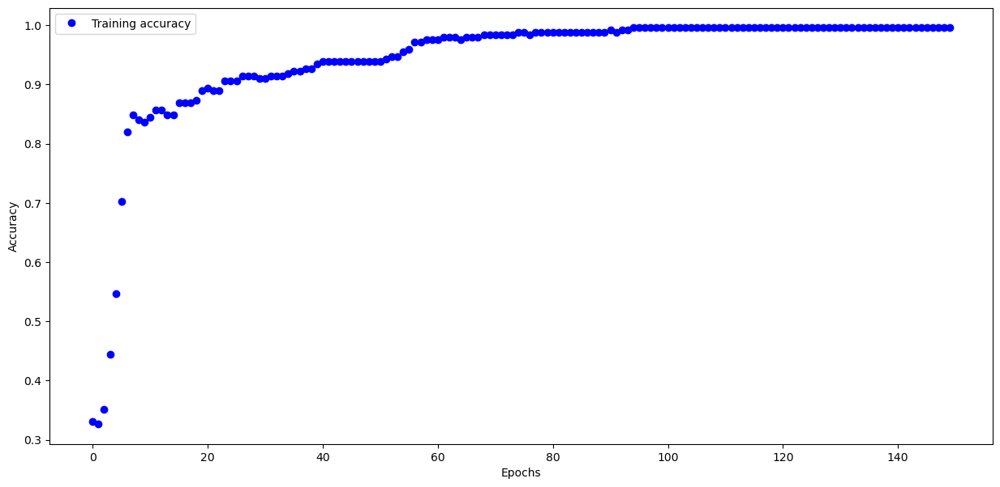

Lab 3

Test accuracy: 0.8855999708175659

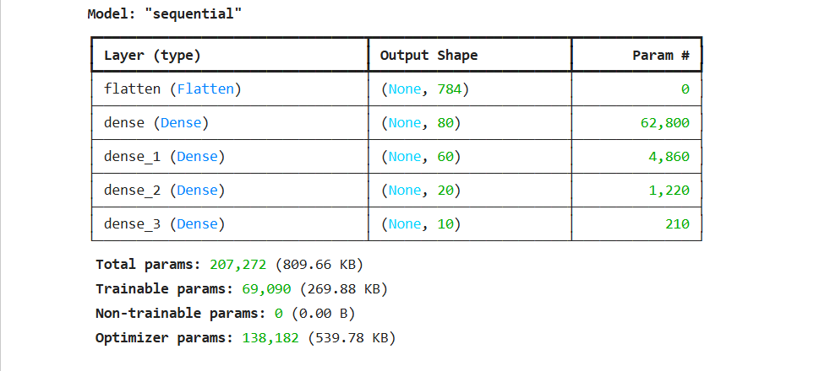

Lab 4

Model’s loss after every epoch

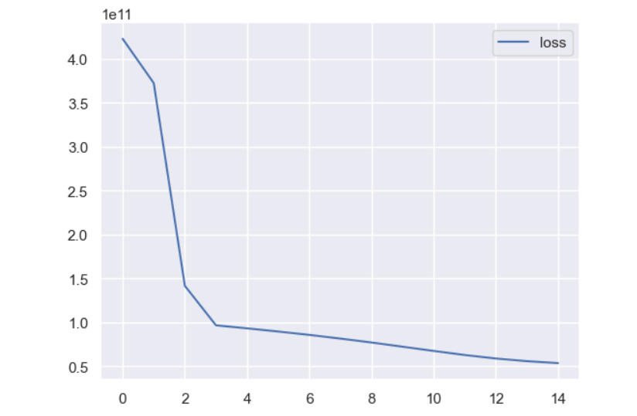

Model summary

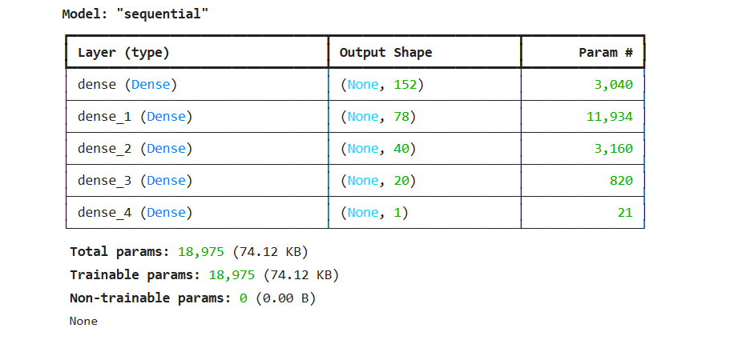

Lab 5

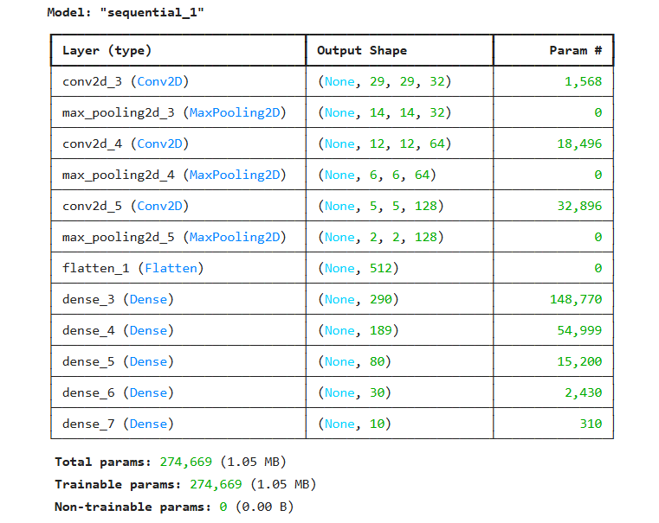

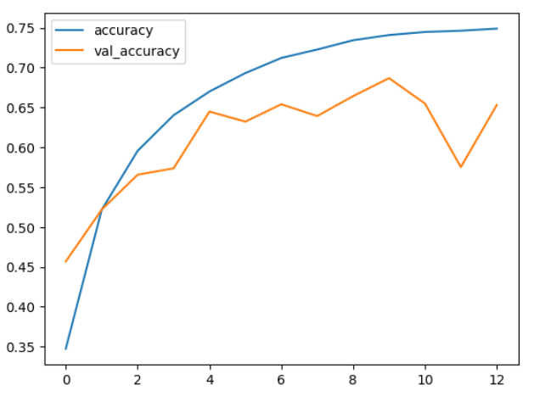

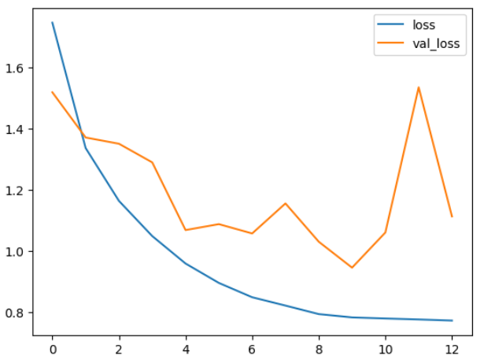

Lab 6

*\*Plot of the 2nd model's summary*

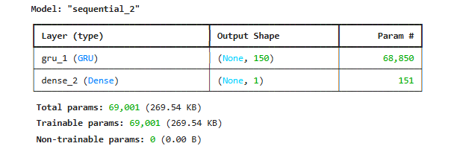

*\*Copy of early-stop code and history_2 fit-training-process*

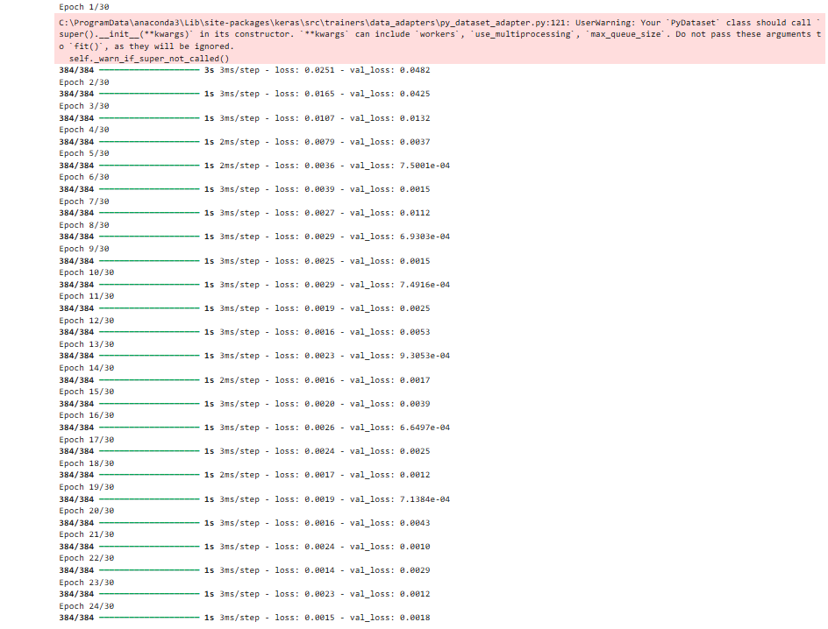

*\*Plot of validation and test loss of history_2*

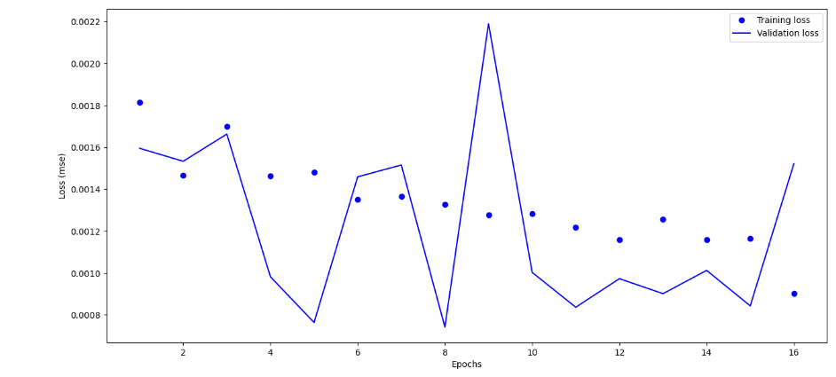

*\*The optimal number of epochs for training model*

Ans : 4

Lab 7

#Graphs for Accuracy and Loss Function for VGG16 and VGG19 (4 graphs in total)

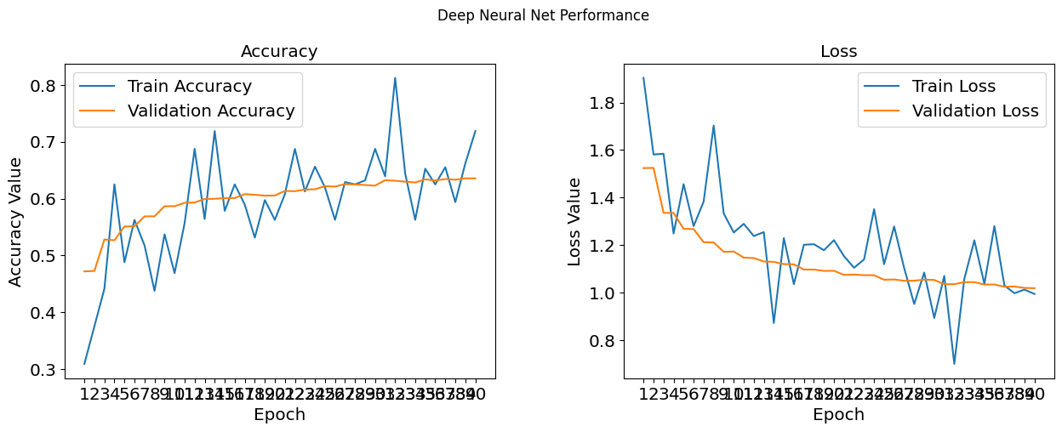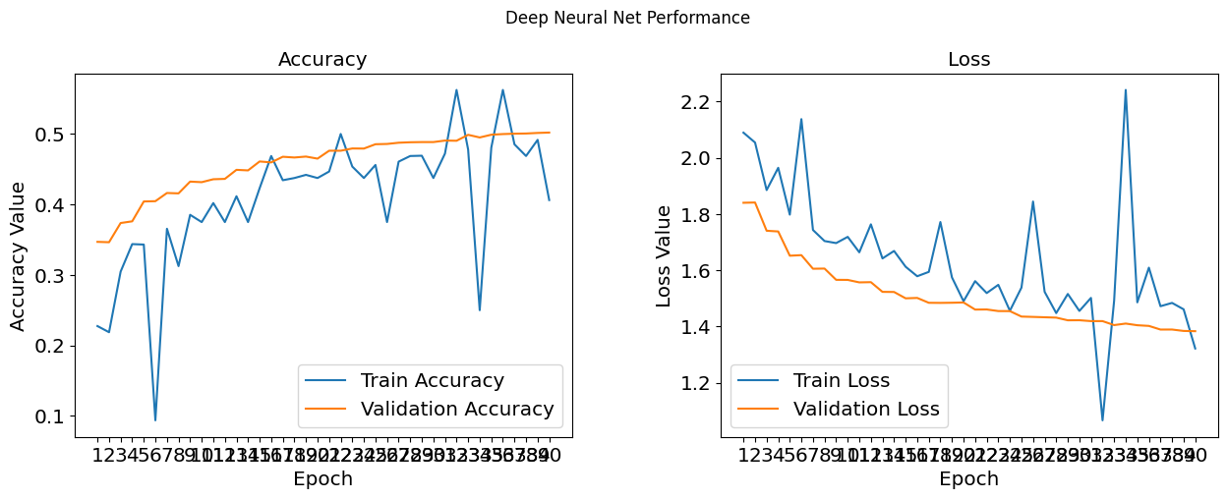

#The optimal number of epochs for training your VGG16 model

Ans:25

#The final Performance Table

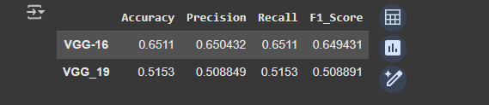

#The performance comparing histogram of VGG16 and VGG19

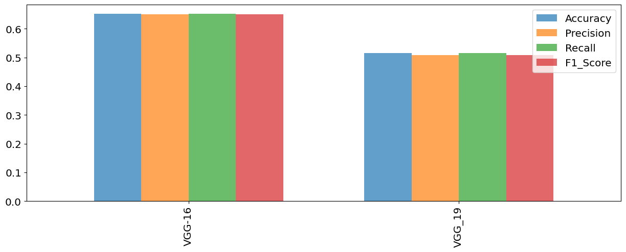

Lab 8

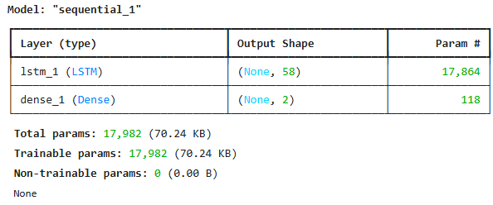

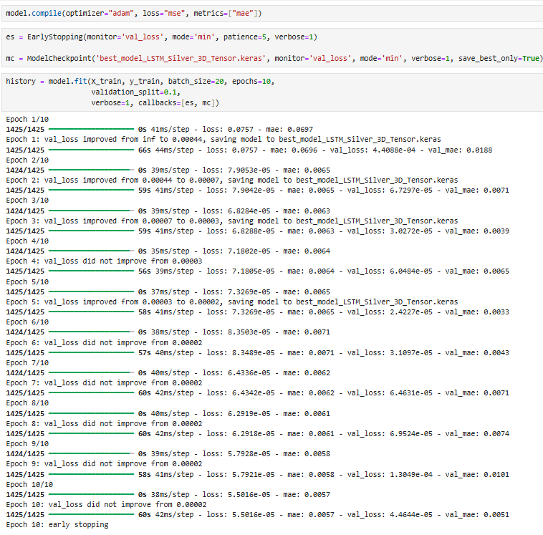

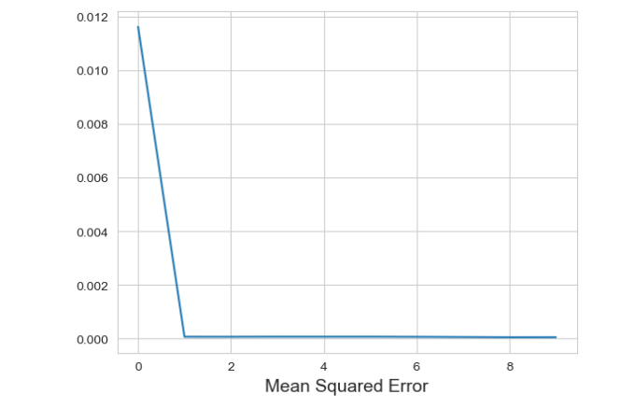

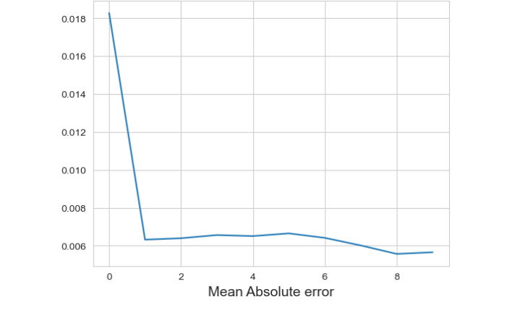

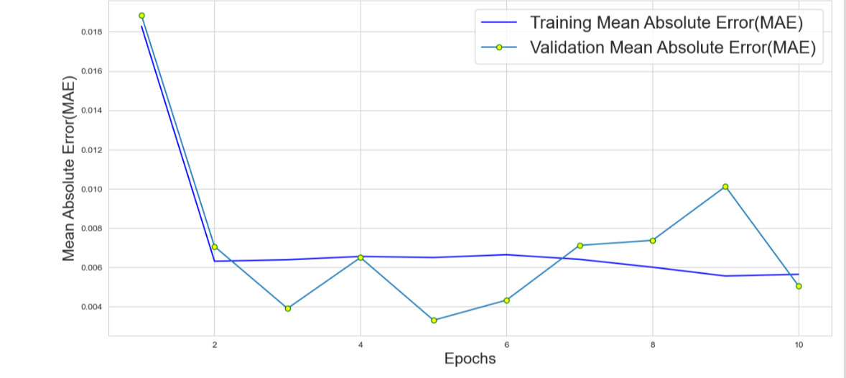

Lab 9

Lab 10

Lab 11

Lab 12